**DAILY ONLINE ACTIVITIES SUMMARY**

|  |  |  |  |  |  |  |  |  |
| --- | --- | --- | --- | --- | --- | --- | --- | --- |
| **Date:** | **04/06/2020** | | | | | **Name:** | **PRANEETA P HANDRAL** | |
| **Sem & Sec** | **4thSEM. & ‘B’ SEC.** | | | | | **USN:** | **4AL19CS401** | |
| **Online Test Summary** | | | | | | | | |
| **Subject** | | **MICRO-CONTROLLER AND EMBEDDED SYSTEMS** | | | | | | |
| **Max. Marks** | | **20** | | **Score** | | | **17** | |
| **Certification Course Summary** | | | | | | | | |
| **Course** | **Python for Machine Learning** | | | | | | | |
| **Certificate Provider** | | | **Greatlearning Academy** | | **Duration** | | | **5 Hrs.** |
| **Coding Challenges** | | | | | | | | |
| **Problem Statement: Write a C++ program to find the missing number in array.**  **Problem Statement:** **write a java program to read three integer values from the keyboard and find the sum of the values. Declare a variable "sum" of type int and store the result in it.** | | | | | | | | |
| **Status:** **Executed.** | | | | | | | | |
| **Uploaded the report in Github** | | | | | **Yes** | | | |
| **If yes Repository name** | | | | | **LockdownCoding** | | | |
| **Uploaded the report in slack** | | | | | **Yes** | | | |

**Online Test Summary:** 18CS44 test was scheduled from 02:00 pm to 02:30 pm. The portion for the IA was 1 st module there were 20 questions and the time assigned was 30 minutes the questions were mcq type. There were 20 questions of 1 marks respectively.

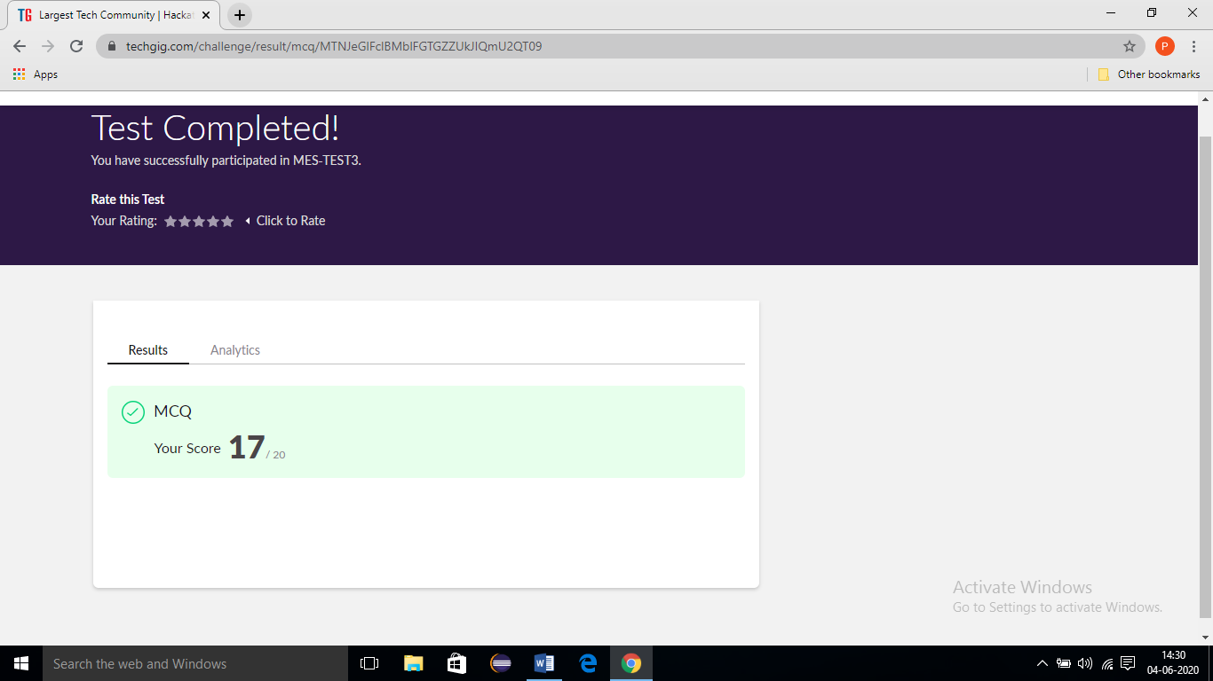

**Online Certification Course Summary:** Today I have learnt about Lambda Function and execute the code and to achieve the output and some of the basic Lambda Function programs. And also today I am attended the test for completion of course and also I score 8 marks in the test finally today I am complete the **Python for Machine Learning** certification course I received certification for **Grate learning academy** and I put snapshot of the certificate below:

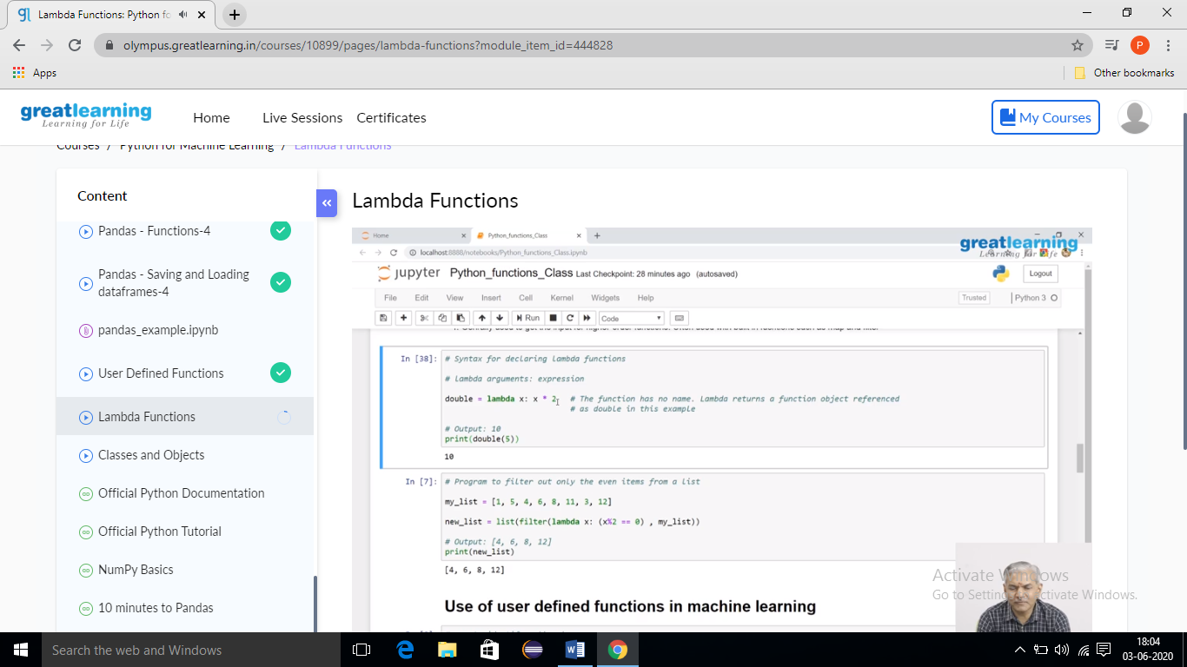

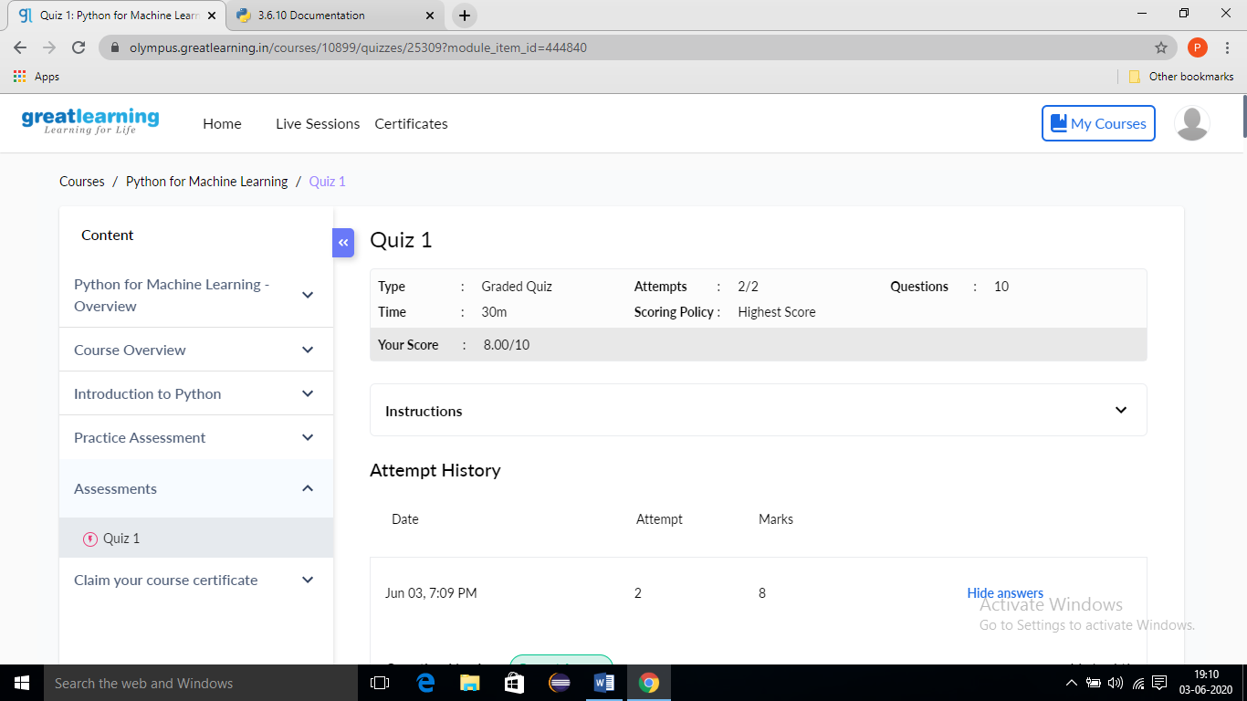

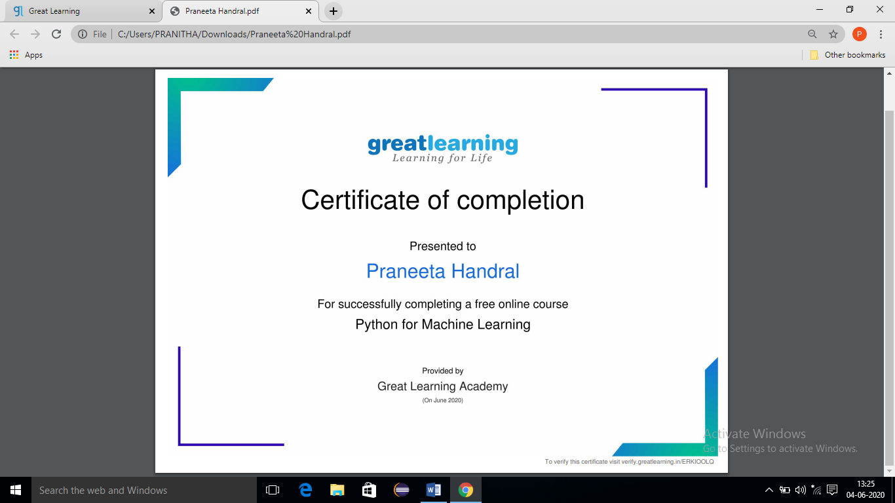

**Online Coding Summary:** Today I received two program from Prof.Venkatesh CSE Dept and another one from Prof. reenalobo CSE Dept. The program is mentioned above. to my GitHub repository and I’ve shared the snapshot below.

